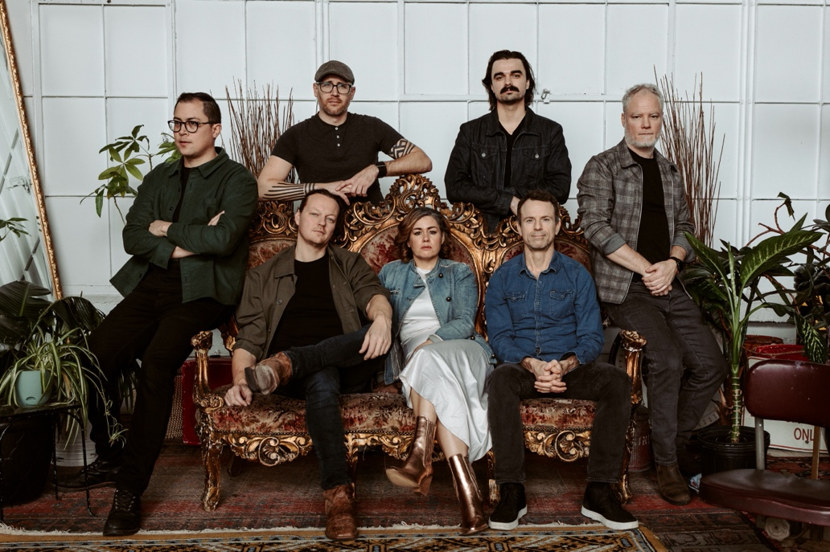

Hi-Res Photos and Video:
Link: Photos
Link: Video Clips

Bywater Call intro:
‘Bywater Call’ out of Toronto, Canada, is a new, exuberant musical hybrid of rock, blues, New Orleans funk, r&b and southern soul.”

Bywater Call Bio:

“A soundscape so epic and electric, it ignited – causing hairs to prickle on the backs of people’s necks. …there was no sense of time or place – just the dream that is good music… there is everything to like about this band”
My Global Mind
“Brilliant songs performed by amazing musicians who left every ounce of energy and sweat on the stage tonight.”
Jace Media

"It’s about time Bywater Call garnered recognition. This is no ordinary band with a standout lead singer. Their songs are written with insight and come from a place of authenticity and meaning. With a tight rhythm section along with Megan Parnell’s righteous voice, Bywater Call is going places."
Rock and Blues Muse

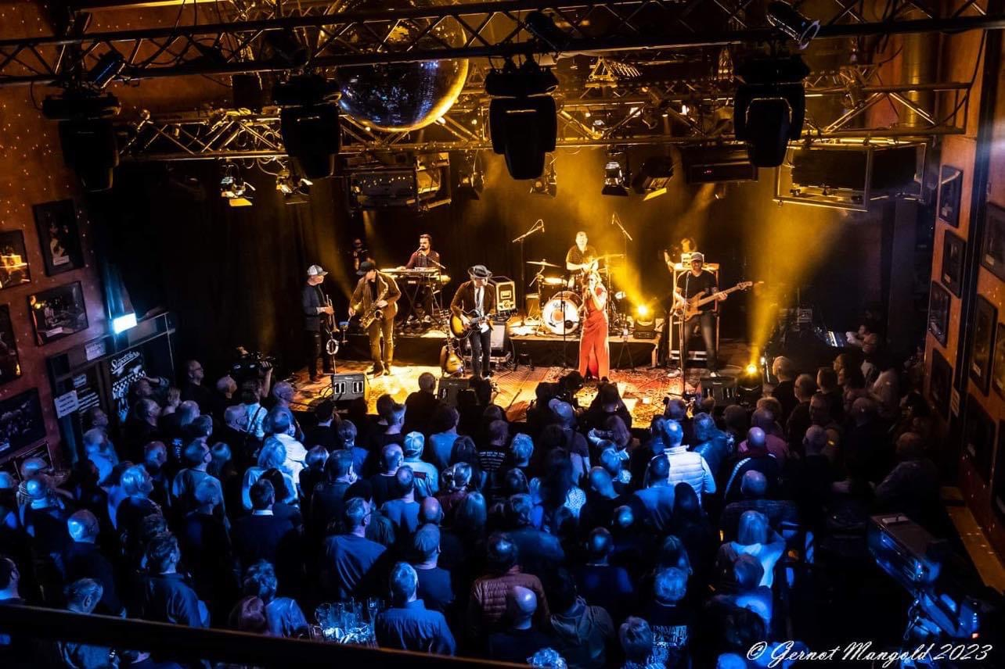

BIO:

Bywater Call, is a powerhouse seven-piece Southern soul, roots rock band from Toronto, Canada, made up of Meghan Parnell (vocals), Dave Barnes (guitar), Bruce McCarthy on drums, Mike Meusel on Bass, newest member, John Kervin on Keys, Stephen Dyte on Trumpet and Julian Nalli on Tenor Sax.

Bywater Call has received multiple Independent Blues and Maple Blues Award nominations including Entertainer, Electric Act and Best Female Vocalist for the 2024 Awards Season. They have toured extensively in Europe where shows have been praised by Dutch, German and UK media, with references to Meghan as one of the best female voices in blues and roots today.

In August 2023, the band participated in Joe Bonamassa’s third Keeping the Blues Alive at Sea Mediterranean Cruise alongside headliners Blackberry Smoke and Christone “Kingfish” Ingram, and were invited to perform at the All-Star Jam on the mainstage with Bonamassa himself. Guitarist Dave Barnes was also asked to join legendary blues artist Jimmy Vivino (Conan O’Brien’s Basic Cable Band) on stage.

Bywater Call have commanded festival stages in Canada and around the world, often referred to as the “find of the fest”. In May of 2023, they opened for Canadian Award-winning band White Horse at the inaugural Smokestack Music Festival in Hamilton, Ontario. In July, Meghan joined renowned pedal-steel guitarist Robert Randolph on stage at his request, at the Briggs Farm Festival in Nescopeck, PA.

On October 24, 2023, Bywater performed a live stream performance for the famed German TV show and festival Rockpalast.

In 2023 alone, the band played a total of 96 shows in 10 countries, 89 Cities, 19 US States and 3 Canadian Provinces. This is not including a month long duo tour in Europe and the UK where Meghan and Dave opened for Southern California rockers Robert Jon & The Wreck, who have recently partnered with Joe Bonamassa’s Journeyman Records.

The band’s music is an exploration of life’s highs and lows. From intimate ballads that lay bare the complexities of human emotion to electrifying anthems that demand to be played at full volume, their catalogue is a journey through the human experience, incorporating influences from the likes of The Band, The Wood Brothers, Tedeschi Trucks Band, Otis Redding, Little Feat, Sly and the Family Stone, among others.

What’s being said about Bywater Call:

“The band collectively produces a joyous mixture of sophisticated musical interplay and a raw soulful energy that sets them far apart from most acts playing the circuit. They have a focused musical vision that centres on the wonderful vocals of Meg and the slide playing of partner Dave Barnes on guitar. To say she’s a powerhouse is an understatement: no screaming involved just pure soulful expression, at a commanding volume. Their songs are equally exceptional.”
Simon Green, Blues in Britain

“an evening of unrivaled blues, rock, and soul fusion. With fiery guitar solos, infectious rhythms, and lyrics that resonate with the human experience, Bywater Call delivered a night of blues-infused bliss that transcended genre and left a lasting impression.”
Extended Play Sessions, Norwood, MA

“Meghan Parnell has one of the most amazing vocals, so powerful and full of emotion. Dave Barnes, on the other hand, is a truly wonderful musician, a master of the slide guitar... I realized quickly that I had indeed been missing out by not finding this band sooner... The soulfulness and grace from the band, and Meghan in particular would have graced any stage in the world."
Blues Matters, UK from Keeping the Blues Alive at Sea

“It’s a 2 hour show of marvellous Americana … a good mix of country, blues, southern rock, and a bit of west coast added for extra trimmings. Man the lady Meghan Parnell can seriously sing, bellowing it out in perfect pitch and hitting every note .. immense, with the band having so much emotion, feeling and colour to their sound.”
Glenn Milligan, Metalliville Zine

“Bywater Call, in a very short two-album career, have already melded blues, rock, roots, soul and country (at least) into an infectious, powerful, enveloping sound. Live, they take these sweet vibes to an electrifying, intoxicating level… absolutely nothing was left behind tonight. The band play with confidence, professionalism and an unshakeable enjoyment in the sheer exuberance of their performance. We’ve had Total Football, heck we’ve had Total War. This was Total Music. One of my gigs of the year. A privilege to be here.”
Dave Atkinson, Get Ready to Rock, UK

“It’s immediately clear that these guys are incredibly talented musicians… singer Meghan Parnell has a voice to die for. Sweet and tender vocals make way for power and steel at the drop of a hat and the emotion in her voice creates a real connection with this crowd early on in the proceedings. Dave Barnes is a guitarist of the highest quality and the rest of the band are no slouches either, with the interplay on the new song ‘Sweet Maria’ being almost mesmeric. The crowd are singing along to this one and it’s just a masterclass of Blues musicianship the way it is performed tonight…”
Jace Media

“Bywater Call’s performance in The Voodoo Rooms, Edinburgh was nothing short of mesmerising. From the moment they stepped on stage, there was an electric energy that permeated the venue. The band’s synergy was palpable, creating an immersive experience that left the audience captivated…

Meghan Parnell’s voice was a force of nature, effortlessly navigating the emotional depth of each song. The lyrics, rich with storytelling, resonated with the crowd, creating an intimate connection between the band and the sell-out crowd…

The instrumental prowess of Bywater Call was on full display, with each member showcasing their musical mastery…

In conclusion, Bywater Call’s gig was a masterclass in live performance. Their musicality, stage presence, and ability to connect with the audience set them apart as a truly exceptional band.”
Stuart Stott, Jace Media

“Dave’s jaw-dropping, pitch-perfect bottlenecking supports Meg’s articulation and frequently ignites the band’s set-pieces into earth-shattering musical extravaganzas… Bywater Call takes you on that journey, up from the Louisiana swamps, along the banks of the Mississippi, and into the silvery city itself... they are a yumptious homestyle band with super-slick big city accomplishments. Wow!”
Raw Ramp

““Bywater Call specialises in tight subtlety, changing feel, rhythm and tempo with seamless ease, with everyone capable of contributing an excellent solo – but the major selling point is the melodic and soulful power of Meghan Parnell’s voice. Not everyone can get to Canada to hear it, but if Bywater Call are on this side of the pond, it would be rude not to.”
Velvet Thunder

“Meghan Parnell … is right up there with the likes of Janis Joplin and Etta James in my humble opinion. A husky, powerful and strong rock/blues voice, her singing looks and sounds so effortless. Like second nature. It was a real joy listening to her going up and down the scale…There is no doubt that this band will make its mark on the UK Blues scene”
Manuela Langotsch, Rockpose

