

PRESS KIT (2025)

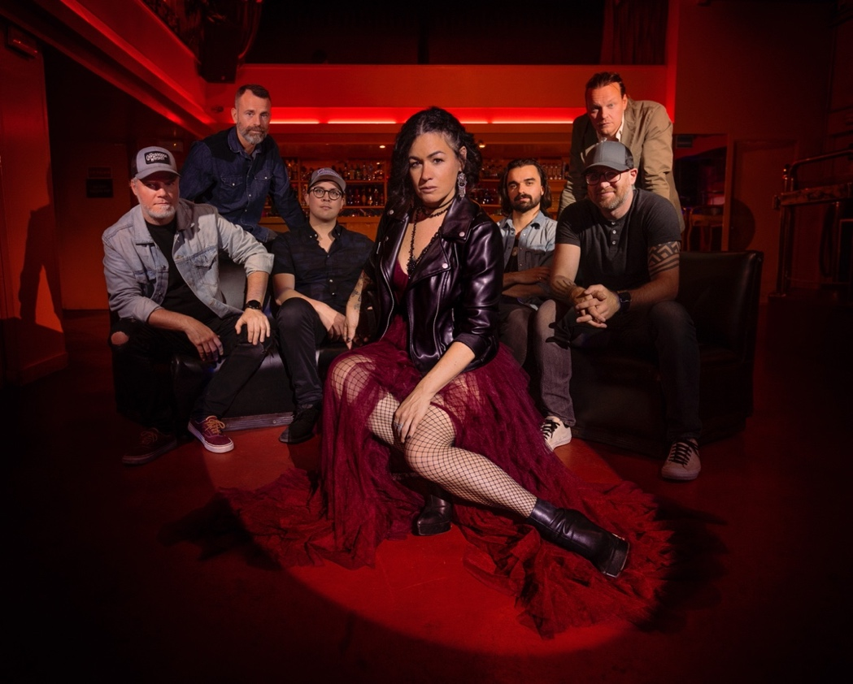

**Hi-Res Photos and Video:**

**](https://www.instagram.com/bywatercall/)[](https://music.apple.com/album/bywater-call/1485895819?ign-mpt=uo%3D4)Link:** [**Photos**](https://drive.google.com/drive/folders/1h3TTQHlZjfCgD_0bpNw5BJD095x7lg3x?usp=share_link)

**Link:** [**Video Clips**](https://drive.google.com/drive/folders/1ugMdXjRTWTZ_rykvjW_thrn9ehHeNDs7?usp=drive_link)

[**Website**](https://bywatercall.com/) **|** [**Facebook**](https://www.facebook.com/bywatercall) **|** [**Twitter**](https://twitter.com/bywatercall) **|** [**YouTube**](https://www.youtube.com/bywatercall) **|** [**Instagram**](https://www.instagram.com/bywatercall) **|** [**Spotify**](https://open.spotify.com/artist/1bhk3AmtYKQAcDzbDyWG4M?si=KqaJIr7YTqakDL3blRlLtg)

**Bywater Call intro:**

*‘Bywater Call’ out of Toronto, Canada, is a new, exuberant musical hybrid of rock, blues, New Orleans funk, r&b and southern soul.”*

***“The sense of a band on the brink is unmistakable.” –*** [***Classic Rock***](https://www.loudersound.com/classic-rock)

***“Bywater Call has a very bright future. I’m sure they will evolve   
into one of the greatest bands in the world.” –*** [***Blues Matters***](http://www.bluesmatters.com)

***“the kind of music you don’t think people make anymore … nothing short of superb.”  
–*** [***Fireworks Magazine***](https://www.fireworksmagazine.com/)

***"It’s about time Bywater Call garnered recognition. This is no ordinary band with a standout lead singer. Their songs are written with insight and come from a place of authenticity and meaning. With a tight rhythm section along with Meghan Parnell’s righteous voice, Bywater Call is going places."***

***Rock and Blues Muse***

**Bywater Call Bio:**

Often transcending genres, Bywater Call is known for their dynamic, emotional live shows, featuring powerful vocals and exciting interplay between all band members.

A powerhouse seven-piece Southern soul, roots rock outfit from Toronto, Canada; the band is comprised of Meghan Parnell (vocals), Dave Barnes (guitar), Bruce McCarthy (drums), Mike Meusel (bass), newest member, John Kervin (keys), Stephen Dyte (trumpet) and Julian Nalli (tenor sax).

***“A soundscape so epic and electric, it ignited – causing hairs to prickle on the backs of people’s necks. …there was no sense of time or place – just the dream that is good music… there is everything to like about this band”***

[**My Global Mind**](https://myglobalmind.com/2023/10/18/bywater-call-thursday-12th-october-waterloo-music-bar-blackpool/)

***“Bywater Call’s gig was a masterclass in live performance. Their musicality, stage presence, and ability to  
connect with the audience set them apart as a truly exceptional band..”***

[**Jace Media**](https://jacemediamusic.com/2023/10/12/bywater-call-the-voodoo-rooms-edinburgh-october-7th-2023/)

In 2024, Bywater Call was **UK Blues Award** nominated for International Blues Artist of the year alongside winners Larkin Poe, after having toured extensively in Europe. Shows have been praised by European media for years, with references to lead singer Meghan Parnell as one of the best female voices in blues and roots today.

They have also received multiple **Independent Blues** and **Canadian Maple Blues Award** nominations including **Entertainer, Electric Act** and **Best Female Vocalist** for the 2024 Awards Season

***“Meghan Parnell’s vocals tear into you from the outset … It immediately lets you know why many in the European music media regard her as one the best blues and roots female vocalists.”***[**At The Barrier**](https://atthebarrier.com/2024/08/02/bywater-call-shepherd-album-review/)

***“Bywater Call’s sound is distinctly their own. While Parnell’s incredible voice is the centerpiece, it isn’t used to cover up any limitations elsewhere in the band. This group is loaded, top to bottom… so tuned into each other that their music and performance seemed flawless.” – Rick Witt,*** [***Denver Entertainment Hub***](https://denverentertainmenthub.com/2024/06/08/bywater-call-ophelias-electric-soapbox-june-6-2024/)

In 2023, Bywater Call played **Joe Bonamassa’s** third ***Keeping the Blues Alive (KTBA) at Sea Mediterranean Cruise*** where Guitarist Dave Barnes was asked to join legendary blues artist Jimmy Vivino (Conan O’Brien’s Basic Cable Band) on stage.

In 2025 the band will once again board to play the KTBA cruise, this time out of Miami, Florida with headliners Big Head Todd and the Monsters and Larkin Poe. Also in 2025, they will play the Netherland’s **BOSPOP** festival alongside the likes of the Black Keys, Snow Patrol, Beth Hart and Melissa Ethridge.

Bywater Call has opened for Canadian award-winning musicians Whitehorse and Tom Cochrane, and singer Meghan has joined renowned pedal-steel guitarist Robert Randolph on stage at his request, at the Briggs Farm Festival in Nescopeck, PA.

Their newest album ”**Shepherd”** has garnered rave reviews from fans and media alike.

***“Shepherd’s blend of rock’n’roll, blues and Southern soul is infectious.” –*** [***R’N’R***](https://www.rock-n-reel.co.uk/)

***“Imagine this: it’s Mardi Gras Night in heaven. The band assembles on stage. There is Otis Redding, Janis Joplin, Lowell George, Sly Stone, Dr. John, Robbie Robertson and The Memphis Horns. This is what Bywater Call sounds like on their third album.” -*** [***Bluestown Music***](https://www.bluestownmusic.nl/review-bywater-call-shepherd/?fbclid=IwZXh0bgNhZW0CMTEAAR1CRNvbd29-Vs10xjjyYti2yPV3Lv42QZn381Ot3_icjcor4Z3nrSXENxQ_aem_jXHgSHBexLji1Ope1DAloQ)

***“Everything about this album oozes class… It’s the sort of record and the kind of music you don’t think people make anymore, and you miss it … It’s nothing short of superb.”  
 –*** [***Fireworks***](https://www.fireworks-magazine.com/)

***“Shepherd is magnificent. It’s roots rock mixed with everything else, with so much crossover appeal it almost defies description.” –*** [***Rock N Load***](https://rocknloadmag.com/news/bywater-call-shepherd-album-review/)

***“Beautifully luscious”***

* [***Louder Sound***](https://www.loudersound.com/.../tracks-of-the-week-august...)

***“‘Shepherd’ offers a journey of different musical expressions with 70s-inspired roots-rock, stunning vocals, and a red-hot band. While the nostalgic feel of the album has a wide appeal, this is a band that is sure to have a bright future: they’re just too good not to”***

* [***Photo Groupie UK***](https://www.photogroupie.com/post/bywater-call-shepherd-review-70s-inspired-roots-rock-with-stunning-vocals-and-a-red-hot-band?fbclid=IwZXh0bgNhZW0CMTEAAR2UaO5-qybv9p22J5Yb3fLe4XK3PaGjvB7_Y-wrJpq20T8XCR4eNx_MHCM_aem_tGIJ-b7Kmpk2PtDmB596IQ)

***“Sheer musical delight from a hugely accomplished group of musicians who know instinctively what each other is about to contribute.”***

* [***Velvet Thunder***](https://www.velvetthunder.co.uk/bywater-call-shepherd/)

The band’s music is an exploration of life’s highs and lows. From intimate ballads that lay bare the complexities of human emotion to electrifying anthems that demand to be played at full volume, their catalogue is a journey through the human experience, featuring influences from the likes of The Band, The Wood Brothers, Tedeschi Trucks Band, Otis Redding, Little Feat, Sly and the Family Stone, and many more. others.

**BYWATER CALL**[**Website**](https://bywatercall.com/) **|** [**Facebook**](https://www.facebook.com/bywatercall) **|** [**Twitter**](https://twitter.com/bywatercall) **|** [**YouTube**](https://www.youtube.com/bywatercall) **|** [**Instagram**](https://www.instagram.com/bywatercall) **|** [**Spotify**](https://open.spotify.com/artist/1bhk3AmtYKQAcDzbDyWG4M?si=KqaJIr7YTqakDL3blRlLtg) **For further information, please contact:**[**bookings@bywatercall.com**](mailto:bookings@bywatercall.com)

**What else is being said about Bywater Call:**

“The band collectively produces a joyous mixture of sophisticated musical interplay and a raw soulful energy that sets them far apart from most acts playing the circuit. They have a focused musical vision that centres on the wonderful vocals of Meg and the slide playing of partner Dave Barnes on guitar. To say she’s a powerhouse is an understatement: no screaming involved just pure soulful expression, at a commanding volume. Their songs are equally exceptional.”

Simon Green, Blues in Britain

“an evening of unrivaled blues, rock, and soul fusion. With fiery guitar solos, infectious rhythms, and lyrics that resonate with the human experience, Bywater Call delivered a night of blues-infused bliss that transcended genre and left a lasting impression.”

Extended Play Sessions, Norwood, MA

“Meghan Parnell has one of the most amazing vocals, so powerful and full of emotion. Dave Barnes, on the other hand, is a truly wonderful musician, a master of the slide guitar... I realized quickly that I had indeed been missing out by not finding this band sooner... The soulfulness and grace from the band, and Meghan in particular would have graced any stage in the world."

Blues Matters, UK from Keeping the Blues Alive at Sea

“It’s a 2 hour show of marvellous Americana … a good mix of country, blues, southern rock, and a bit of west coast added for extra trimmings. Man the lady Meghan Parnell can seriously sing, bellowing it out in perfect pitch and hitting every note .. immense, with the band having so much emotion, feeling and colour to their sound.”

Glenn Milligan, Metalliville Zine

“Bywater Call, in a very short two-album career, have already melded blues, rock, roots, soul and country (at least) into an infectious, powerful, enveloping sound. Live, they take these sweet vibes to an electrifying, intoxicating level… absolutely nothing was left behind tonight. The band play with confidence, professionalism and an unshakeable enjoyment in the sheer exuberance of their performance. We’ve had Total Football, heck we’ve had Total War. This was Total Music. One of my gigs of the year. A privilege to be here.”

Dave Atkinson, Get Ready to Rock, UK

“It’s immediately clear that these guys are incredibly talented musicians… singer Meghan Parnell has a voice to die for. Sweet and tender vocals make way for power and steel at the drop of a hat and the emotion in her voice creates a real connection with this crowd early on in the proceedings. Dave Barnes is a guitarist of the highest quality and the rest of the band are no slouches either, with the interplay on the new song ‘Sweet Maria’ being almost mesmeric. The crowd are singing along to this one and it’s just a masterclass of Blues musicianship the way it is performed tonight…”

Jace Media

“Bywater Call’s performance in The Voodoo Rooms, Edinburgh was nothing short of mesmerising. From the moment they stepped on stage, there was an electric energy that permeated the venue. The band’s synergy was palpable, creating an immersive experience that left the audience captivated…

Meghan Parnell’s voice was a force of nature, effortlessly navigating the emotional depth of each song. The lyrics, rich with storytelling, resonated with the crowd, creating an intimate connection between the band and the sell-out crowd…

The instrumental prowess of Bywater Call was on full display, with each member showcasing their musical mastery…

In conclusion, Bywater Call’s gig was a masterclass in live performance. Their musicality, stage presence, and ability to connect with the audience set them apart as a truly exceptional band.”

Stuart Stott, Jace Media

“Dave’s jaw-dropping, pitch-perfect bottlenecking supports Meg’s articulation and frequently ignites the band’s set-pieces into earth-shattering musical extravaganzas… Bywater Call takes you on that journey, up from the Louisiana swamps, along the banks of the Mississippi, and into the silvery city itself... they are a yumptious homestyle band with super-slick big city accomplishments. Wow!”

Raw Ramp

““Bywater Call specialises in tight subtlety, changing feel, rhythm and tempo with seamless ease, with everyone capable of contributing an excellent solo – but the major selling point is the melodic and soulful power of Meghan Parnell’s voice. Not everyone can get to Canada to hear it, but if Bywater Call are on this side of the pond, it would be rude not to.”

Velvet Thunder

“Meghan Parnell … is right up there with the likes of Janis Joplin and Etta James in my humble opinion. A husky, powerful and strong rock/blues voice, her singing looks and sounds so effortless. Like second nature. It was a real joy listening to her going up and down the scale…There is no doubt that this band will make its mark on the UK Blues scene”

Manuela Langotsch, Rockpose